Requirements/Design Specification

**Request fields in XML from InfoPro**

**GH 356 – CR 13940**

Revision History

|  |  |  |  |
| --- | --- | --- | --- |
| **Date** | **Revision** | **Description** | **Author** |
| 5/28/2015 | 1.0 | Initial Version with Requirements | Roger Behm |
|  |  |  |  |
|  |  |  |  |
|  |  |  |  |
|  |  |  |  |

The information furnished herein by Republic Services Inc. is proprietary and confidential to Republic Services Inc. personnel and is not to be duplicated, published, or disclosed to any third party in whole or in part without permission from Republic Services, Inc.

© Copyright 2012, Republic Services Inc. - All rights reserved.

Table of contents

1 Business Requirements/Owner – Brittany Smith 6

2 Assumptions 6

3 Design 6

4 InfoPro/TIBCO/BI Impacts 6

5 Report Changes 6

6 Appendix 6

# Business Requirements/Owner – Brittany Smith

For a Change of Owner, the Customer Site Information is not and should be required. Once the Select Customer search is completed and populates the site address, it appears no validation is performed when clicking next and the application advances to the Select Service Offering Screen

# Assumptions

NA

# Design

A new Commerce Validation Rule (siteInformationValidationForChangeOfOwner) needs to be written to check that if industry, segment, authorized by, site name, contact name, and email are empty for a change of owner quote, a rule violation occurs informing the user to fill out any empty fields.

This should be made in a similar fashion to other validation rules for site information, for example: Site Information validations for Existing Customer.

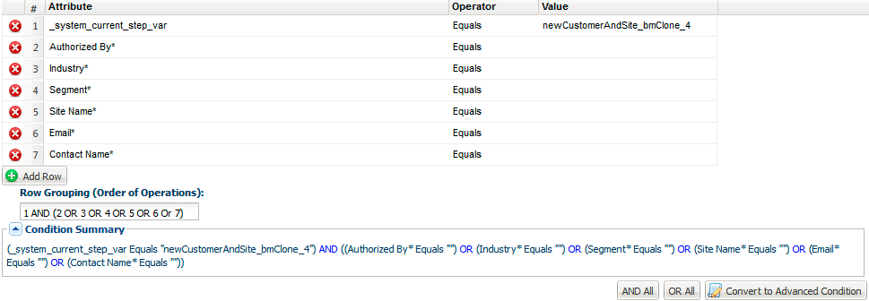

# InfoPro/TIBCO/BI Impacts

New varrible names to be added here:

None

# Report Changes

NA

# Appendix